**Task 2**

1. Do all arthimetic operator in one single program

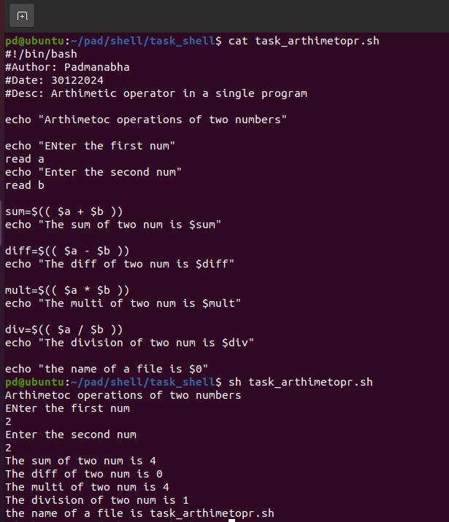

1. Explore special variables
2. $* = This variable holds all the arguments passed to the script or a function as a single string.
3. $$ = This variable gives the Process ID (PID) of the script or the current shell instance.
4. $! = This variable holds the process ID of the most recently executed background command. It is used to get the PID of processes that are running in the background.
5. create a file or directory check that is it file or directory (file opeartor)

